Dzie-Hauk Tonga Lodge Honors Book

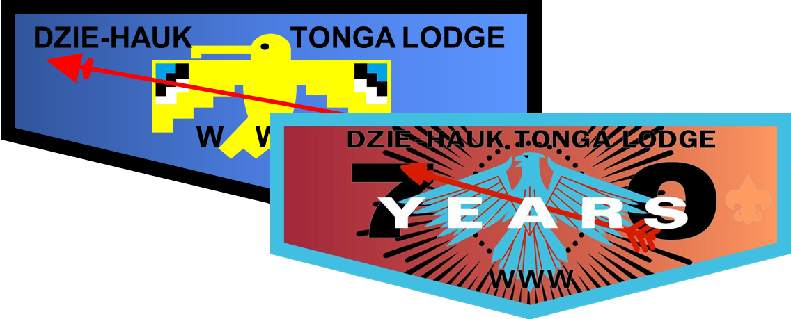

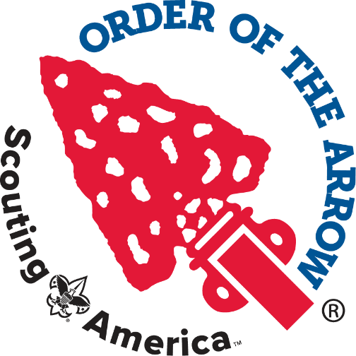
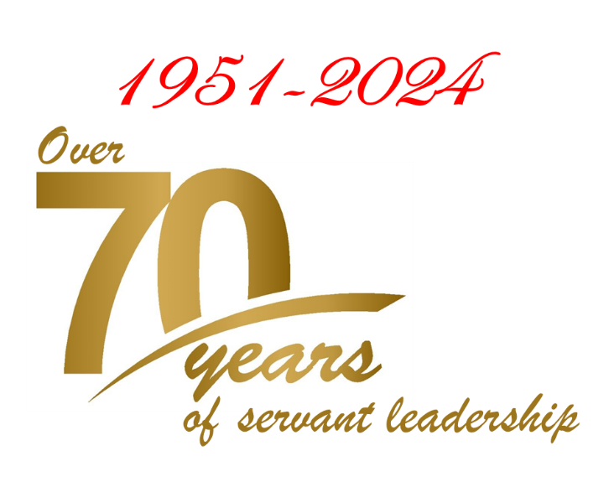

“He who serves his fellow man,
is of his fellows
greatest.”
-Uncas, in the Legend of the Order of the Arrow

This book is dedicated to the Arrowmen of
Dzie-Hauk Tonga Lodge,
past, present, and future.
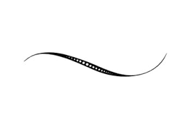
To James Galvin, Adviser, mentor, friend and brother.
This book was first assembled and written by George Waters
and is currently maintained by Josh Evans.

The Distinguished Service Award
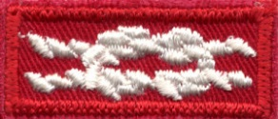
The Distinguished Service Award (DSA) was created in 1940 to honor those who rendered service to the Order beyond the lodge level. The award is presented to Arrowmen, youth and adult, who have rendered distinguished and outstanding service to the Order on a sectional, regional, or national basis. The award is presented at National Order of the Arrow Conferences. Since the time the first awards were presented, less than 1000 Distinguished Service Awards have been awarded.

The award is a sterling silver arrowhead bearing an arrow pointing up and to the wearer's right. The award is suspended from a white neck-ribbon on which red arrows are embroidered. A white square knot embroidered on red cloth is available for uniform wear and a silver arrowhead lapel pin is available for civilian wear.

Dzie-Hauk Tonga Distinguished Service Award Recipients
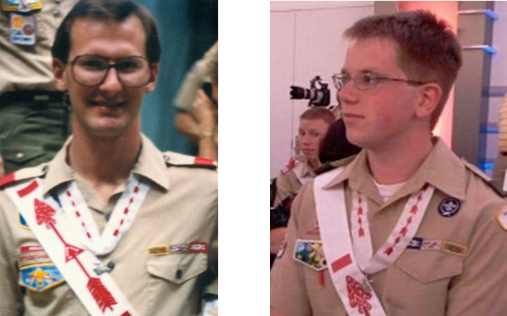
1986 Kevin Hula 2012 Collin Huerter

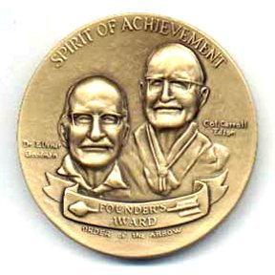
The Founders Award
The Order of the Arrow Founder's Award is the highest national award given at the lodge level. It was first introduced at the 1981 National Order of the Arrow Conference (NOAC), following the death of
Dr. Goodman.

This award honors Arrowmen in the OA for unselfish service above and beyond their normal duties to their lodge. Our lodge may present the award to up to two arrowmen annually, but one must be a youth under 21 years old. Lodges are not required to give the Founder's Award if they feel that no one is worthy of it. A member may only receive the award once in his or her life

The award is a bronze medallion bearing the images of founder E. Urner Goodman, and cofounder Carroll A. Edson. The reverse of the medallion read "For he who serves his fellows, is of all his fellows, greatest" which was Goodman's prime reason for starting the Order of the Arrow. The recipient is also presented with a certificate detailing his or her name and lodge and a red ribbon with gold arrow
for the uniform.

Dzie-Hauk Tonga Founder's Recipients

1982 Curtis Wagner, Jack Gies
1985 Kevin Hula
1988 Ray Culp
1990 David Brosa, Craig Dunstan
1982 Curtis Wagers, Jack Gies
1985 Kevin Hula
1988 Ray Culp
1990 David Brosa, Craig Dunstan
1994 Joshua Sales, Vern Failor
1995 Jason Wiley, John Kleinschmidt
1996 Chris Austin, Leonard Grey
1997 Richard Hinkston, George Austin
1998 James Bennett, Paul Polansky
1999 Tony Hoch, Roy Stanton
2000 Derek Bucheit, Ken Stabb
2001 Shawn Weldin, Sue Austin
2002 Chris Frampton, Mike Johnston
2003 Ken Weaver, David Young
2004 Alex Ast, David Ast
2005 Andy Weaver, Reed Davis
2006 Nathan Huerter, Jim Erwin
2007 Brian Jilka, Jim Allman
2008 Chris Ashley, Charles Ashley
2009 Kevin Dawson, Bertra Manning
2010 Collin Huerter, Marvin Coker
2011 James Manning, Mike Ballard
2012 Mark Spicer, Jason Biggs
2013 Aaron Spicer, George Waters
2014 Thomas Bagley, Jeff Thompson
2015 Brenden Feldt, William “Brock” Lowman
2016 Paul Riley, Steve Marcotte
2017 Cole Resnik, Matt Riley
2018 Dalton Leek, Rick Huddlestun
2019 Stephen Caudill, Tony Leek
2020 Samuel Mazas, John Gray
2021 Andrew Kirmer, Dale Kirmer
2022 Nathan Basaldua, Joe Pilsl
2023 Ethan Kebert, Chris Wagner
2024 Brenner Pilsl, Lynda Riley

James E. West Fellowship Award
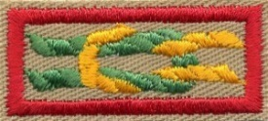
The James E. West Fellowship Award is a national recognition created in 1993 and presented to individuals who contribute $1,000 or more in cash or securities to their local council endowment trust fund.

Dzie-Hauk Tonga Lodge periodically contributes to the fund in the name of an honoree the lodge wishes to recognize for service to the lodge.

The award is named after the first Chief Scout Executive of the Boy Scouts of America who exemplified Ralph Waldo Emerson's observation that "an institution is the lengthened shadow of one man." Scouting today is the "lengthened shadow" of more than three decades of the farseeing and dedicated leadership of Dr. James E. West.

Those who are recognized by the James E. West Fellowship Award will cast their own “lengthened shadow” as they help ensure the Scouting legacy for future generations of young people and create the financial stability of the program in the twenty-first century for their local council.

Dzie-Hauk Tonga James E. West Honorees
2007 Andrew Tate
2008 Chuck Ashley
2009 Kevin Dawson
2010 Tyson Marcotte
2011 James Manning
2012 Jacob Calander, Aaron Spicer
2013 Gerard Nasca
2014 Mark Spicer
2015 Daniel Xidis, Wayde Brozek
2016 Thomas Bagley, Nick Kirmer
2017 Tobias Mikkelsen
2018 Brenden Feldt
2019 Paul Riley
2020 Nathan Basaldua, Clayton Pilsl
2021 Josh Evans
2022 Caden Rossillon
2023 Andrew Kirmer
2024 Kaylin Phillips, Nate Waters

Vigil Honor
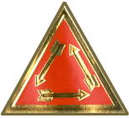
The Vigil Honor is a high mark of distinction and recognition reserved for those Arrowmen who have made distinguished contributions to the OA or scouting. Any member of the OA registered in Scouting and in good standing with the lodge are eligible to receive the vigil provided they have been a brotherhood member for at least 2 years. Nominations can be submitted by any lodge member but no more than 2% can be chosen. They are elected by a vigil committee made up of lodge youth members and at least half of those chosen under 21 years old. Since 1953 our lodge has selected over 400 vigil candidates including former Chief Scout Executive Roy Williams, in 1984.

Dzie-Hauk Tonga Lodge Vigil Honorees
1953
Don Graves - Saken Allanque - Shooting Star
Larry Hansen - Achewon Achpateuny - Strong East Wind
Dr. Clyde Merideth - Nachqohuman Woapalanne - Singing Eagle

1955
Ruwal Freese - Tatchen Meechqalanne - Little Hawk
Howard Johnson - Salamoagan Wiechcheu - Howling Coyote
John H. McDaniel - Tqauchsin Quekolis - Friendly Whippoorwill
Ronnie Ott - Tatchen Kschihillen Wiechcheu - Little Swift Wolf
Thomas Joseph Sneden - Wulatschimolsin Tpoquik - Friendly Moon
Carl J. Twinning - Wulantowagan Pommauchsowagan - Spirit of Life

1956
Charles C. Cason - Juhuk Awehhellen - Calling Bird
George Fredrick Epps - Wschimuin Woapalanne - Soaring Eagle
Dan Jansen - Wisaweu Woaphokquawon - Yellow Hair
Larry Longhofer - Tatchen Wipunxit Wiechchen - Little Gray Wolf
Leon D. Peterson - Amangi Wschimuin Meechgalanne - Big Flying Hawk
Wade Pierce - Woapalanne Achschiechey - Eagle Nest
James Pulliam - Witscheman - Indigo Bunting
Harvey J. Ray - Amangi Alalechet Achguikbi - Big Dying Elm
Don Simon - Woapalanne Wsit - Eagle Foot
Jack Warner - Machkeu Mehakachtey - Glowing Ember

1957
Michael L. Ballard - Tschitqui Quenischquncey - Silent Panther
John Basile - Wschimuin Amangamek - Flying Fish
Norman Burkhead - Machkeu Sachapiwak - Red Lightning
William Kipper - Amangi Wipunquoak - Great Oak
Kenneth Lenke - Pedhakquon Awehhellen - Thunderbird
Joseph E. Macy
Richard Mistler - Majawi Alluns - Straight Arrow

1958
Elmo Clark - Peptukquekhikenk Meechgalanne - Circling Hawk
Lyle F. Holm - Achewon Alluns - Sturdy Arrow
Simon P. Johnson - Amangi Wschimuin Kaak - Great Flying Goose
Everett E. Lewis - Wschimuin Tschihoapekelis - Flying Blue Jay
Louis G. Linn - Pakallohu Tschukquilques - Cheering Locust
Larry Patterson - Amangi Sapiwagan - Great Lightning
Robert Thomas Jr. - Wapsu Meechgalanne - White Hawk
Myron Tweedy - Amiga Alluns - Long Arrow
Phil Wheeler - Tetchen Temahikan - Little Tomahawk

1959
Mark Roberts

1960
John Pat Atkinson – Tscholentit - Little Chickadee
A. J. Basile - Amangi Wschimuin Amangamek - Big Flying Fish
Robert Brosa - Machkeu Blaknik - Flying Red Squirrel
Dennis Domer - Tindey Pisgeu - Fire Night
Zeno Drummond - Amangi Hittuk - Big Tree
Walter Scott Kenton - Tindey Gentgeen - Flames That Dance
Ken Lowry - Tatchen Ktemaque - Little Beaver
Lonny Smelser - Sukeu Mos - Black Elk
Walter G. Stumbo - Amangi Schiwapew Lowulen - Big Blue Flame

1961
Roy Ballard - Amangi Majawi Alluns - Big Straight Arrow
Scott Cram - Tetchen Skattewi Woapalanne - Little Blazing Eagle
Signor Fink - Schiwa Opew Sachapiwak - Blue Lightning
Theodore A. King - Petasemowik Allanque - Shining Star
Larry Magnuson - Sukeu Welchos - Black Stallion
Fred C. Tiffany - Tatchen Wachejeu Allanque - Little Bright Star

1962
George C. Anderson - Amangi Machque - Big Bear
Robin R. Domer - Tangitti Tindey Pisgeu - Small Fire Night
Thomas C. Gatie - Sisilija - Bison
David C. Gleason - Tatchen Tpoquik Nipahwochwen - Little Moon Traveler
Arthur E. Myers - Wapsu Machque - White Bear
Joseph R. Phillips - Lippoewina Woakus - Sly Fox
Gordon E. Snyder - Ktschinguehhellen Gischuch - Rising Sun
William Mike Shimeall - Tangetto Nachgohuman Woakus - Wee Singing Fox

1963
W. Rod Alward – Wulowachtauwoapin - Farsighted One
James Dobkins - Tatchen Alluns Wil - Little Arrowhead
Charles L. Gleason - Amangi Wteltschenemen Achsin - Big Rolling Stone
Arthm H. Griggs - Tatchen Kikey Woapalanne - Little Old Eagle
Ralph M. Malott - Gischgu Tpoquik - Day Moon

1963 (Continued)
Harold Swenson – Achsinemhoan - Silver Dipper
Rowan E. Tichenor - Klamachpim Wulachneu - Whispering Brook
Frank C. Virr - Amiga Schukuney - Long Trail
Charles W. Wright III - Sukeu Wsit - Blackfoot

1964
Lauress Collister - Nechaha Netopalis - Lone Scout
Kenneth A. Domer - Tatchen Tindey Pisgeu - Little Fire Night
W. Daniel Land - Pedhakquon Tindey - Thunderfire
Gene Lyons - Allun Topalowilenno - Dog Soldier
Ralph A. Malott - Amangi Gischgu Tpoquik - Big Day Moon
A. T. Steadman – Woaktschiechen - Winding Trial
Robert L. Weide - Geeschtek Tindey - Hot Fire
James A. Wingrave - Woapelechen Lowulen - Silver Flame
Charles W. Wright Jr.- Amangi Sukeu Wsit - Big Blackfoot

1965
Duke Collister
Mike Francis - Wapsu Allanque - White Star
Keith Kelsey – Sukeu Wapsu Quenischquney – Spotted Panther
Don Land
Bill Land
Joseph M. Thomas
Wayne Vawter - Amangi Wschimun Woapalanne - Big Flying Eagle
Randy Whelpley - Wapsu Wachtschu - White Mountain

1966
William A. Brown – Wikathoos - Coffee Pot
Robert Callahan - Tatchen Kschihillen Mamalis - Little Fleet Fawn
Erie W. Francis - Mechen Wapaleechen Allanque - Big White Star
Charles E. Goldsmith - Wisaweu Welclious - Golden Stallion
Jeffrey E. Jordan - Tatchen Sukeu Meechqalanne - Little Black Hawk
Larry King – Kuwewanik - Red Squirrel
Jesse F. Long - Amangi Nechoha Woapalanne - Big Lone Eagle
Mike Long - Nechoha Woapalanne - Lone Eagle
William R. Ludwig - Tatchen Gentgeen Machque - Little Dancing Bear
Larry Mah - Loaktschehellen Wisamek - Jumping Catfish
Stanley Ross - Gunaquot Woapalanne - Tall Eagle

1967
Allan Bacon - Gihim - One Who Encourages
Raymond D. Bass - Tschitanitehen - Persevering One
Vernon F. Brumbaugh – Machque- Bear
Tom M. Collister – Wischixin - Active One
Larry Ferren – Eluwilfsit - Gracious One
Raul Guerrero – Tqauchsin - Friendly One
Harold G. Jasperson – Machkeu - Red
Merle Nunemaker - Leke - Loyal One
Herb Nunemaker Jr. - Gawi - Badger

1968
Charles M. Blakely - Meschiechan Allanque - Falling Star
Roy O. Young - Amangi Woapalanne Wikasch - Big Eagle Claw
John Goodale - Tilghman Nechasin Ktemaque - Watchful Beaver
Donald G. Schaffner - Nechoha Wechcheu - Lone Wolf
Mark Hunt – Sukamek - Black Fish
Gary L. Domer - Mechen Tindey Pisgeu - Big Fire Night

1969
David S. Blakely - Wowoatam - Skillful One
Benjamin Brunner - Bischik Mawat - Sure One
Kurt D. Buchanan - Ehalluchsit Mawat - Powerful One
Allan E. Cameron - Pommissin - He Who Goes Afoot
Lee Elfred Fry – Tschutti - Comrade
Jack B. Gies Jr. - Ateukpatton - Fireman
Charles A. Luckinbill – Wapsu - White
Kenneth McDonald - Elauwit - Hunter
Carl W. Ossmann – Luppoewagan - Witty One
Jerry Ruggert – Witscheman - Helpful One
Laurence Y. Waters – Tangetto - Small One

1970
Frederick H. Budden – Wischixin - One Who Exerts Himself
Michael A. Cameron - Tatchen Pommissin - Little One Who Goes Afoot
Frank T. Forbes – Wulamoc - He Who Speaks Truly
Jack B. Gies - Amangi Ateunkpatton - Big Fireman
Martin L. Gies - Tetchen Ateunkpatton - Little Fireman
Thomas E. Granger - Woalpalonne - Bald Eagle
Leon H. Mannell – Gischhatten - One Who is Ready
Mark L. Mannell - Tatchen Gischhatten - Little One Who is Ready
John B. Ossmann – Witatschimolsin - One Who Holds Councils
Wayne Sawyer – Tschitanissohen - One Who Strengthens
Dean R. Stewart - Nagatamen - One Who Can Be Trusted

1971
Kent Anschutz - Wacheieu Machkeu Alluns - Little Red Arrow
David R. Ast - Tatchen Quenischquney - Silent Panther
Randy Bartley - Klampeechen - Still Water
Alan Demoss - Gischitehen Sachgachtoon - Determined Cook
William E. Cowen - Mechen Sukeu Machque - Big Black Bear
Ed. V. Kreipe - Amangi Nuwing Sisilija - Big Willing Buffalo
Richard E. McCoy - Wipunxit Gawi - Gray Badger
James F. Miller - Amangi Wipungweu Wiechcheu - Big Brown Wolf
Richard Oliva - Tatchen Achsin Machque - Little Stone Bear
Mark Schirkofsky – Gischihan - One Who Creates with His Hands

1972
Glenn Anschutz - Amangi Machkeu Alluns - Big Red Arrow
Melvin Cowen - Tatchen Sukeu Machque - Little Black Bear
Fredrick R. Budden - Amangi Wischixin - Big One Who Exerts Himself
Kent Erickson - Achqamen Kuwe Mehittuk - Broad Pine Tree
Joseph M. Garcia - Wulihan - He Who Does Good for Others
1972 (Continued)
Reed Lindholm - Pilwetschitsch Elauwit - Boy Hunter
Paul Martin - Achqiguwen Gokhos - Noisy Owl
Jeffrey J. Montague - Allohak Sisilija - Powerful Buffalo
Ray Van Orsdol - Amangi Eluwak Nenajunges - Big Powerful Horse

1973
Gary Armstrong - Awullsu Mikemassit - Good Worker
J. Eugene Brubaker - Pakanatschiechem Ktemaque - Accomplished Beaver
Virgil Cowen - Sukeu Machque - Black Bear
Walter E. Erickson - Amangi Achqumeu Kuwe - Big Broad Pine Tree
Warren E. Granger - Tschitanissowagan - Capable One
Rich Morgan – Segachtek - Ardent One
Art Saville - Tgauchsin Woapalanne - Friendly Eagle

1974
Mark Anschutz - Tatchen Machkeu Alluns - Bright Red Arrow
Brant Bailey - Wowoatam Achqook - Skillful Snake
Mike Decker - Wowoatan Hattape Lenno - Skillful Bowman
Charles A. McKinney - Amangi Wapsu Sisilija - Great White Buffalo
Loren Meyer - Tschitgussin Witschindin - Silent Helper
Bruce Money - Gunaquot Wapsu - Tall White
Joe H. Oliva - Amangi Achsin Machque - Great Stone Bear
Carl L. Stewart - Amangi Pennauweleman Allanque - Great Thoughtful Star

1975
Paul Bargas - Allohak Machque - Strong Bear
Robert Beckman – Najundam - One Who Carries a Load
Jan Dutcher - Nagatamen Takachsin - Reliable Leader
Carlan D. Honaker - Amangi Lippoe Gokhos - Big Wise Owl
Charles Howard Jr. - Kschamehhellan Sisilija - Running Buffalo
Charles N. Howard Sr.
Scott Miller - Tatchen Wipungweu Wiechcheu - Little Brown Wolf
Robert Oliva - Tangetto Achsin Machque - Small Stone Bear
David Wilms - Nechachwen - He Who Travels Alone

1976
Mike Hall – Wulowachtauwoapin - He Who Looks Beyond
Lane A. Hollern – Apatschin - One Who Comes Back
Frank N. Holliday – Wunita - One Who Knows How
Dennis Mize - Gischitehen - Determined One
Ted Mize - Wischixin - One Who Exerts Himself

1977
Charles Greenlief - Achqeketum - Teacher
Michael Greenlief - Tschitanek Aschowin - Fast Swimmer
Don C. Rubart - Leke - He Who is True
David A. Thomason

1978
Jon Walters - Anatschihuwewagan - Cautious One
Bruce Wiley - Mawat Nagatamen - One Who is Trusted
Ralph M. Young Jr. - Tschitanissahen - One Who Strengthens
James C. Zahourek - Nuwingi - Willing One
James J. Zahourek - Alappiechsin - Fast Talker

1979
David Bevens – Allogaaan - He Who Serves
Scott Capes – Lowanachen - North Wind
Les Flake – Sachgachtoon - Cook
Cliff Greenlief – Kschamehhellan - Fast Runner
David W. Levy – Nuwingi - Willing One
David B. Mannell - Nachgohuman - One Who Sings
Tom McClure - Wulaptonen - He Who Speaks Favorably
Elmer M. Miltz - Woaphokquawon Machmauwikemk - Grayhaired Camper
Roy Scott Thomas - Sukachsin Nenajunege - Iron Horse

1980
Dan P. Baumchen - Nagatamen - Reliable One
Todd Daeschner - Lippoe Mechmauwikenk - Experienced Camper
Troy Daeschner - Achewon Lekhiket - Strong Writer
Roger Daeschner - Woaphokquawon Mikemossit - Grey Haired Worker
Dale Parnell - Gischenaxin Sachqachtoon - He Who is Prepared to Cook
Rick Pressgrove - Lilchpin Witscheman - Willing Helper
Blake Rolley - Apatschin - He Who Comes Back
Robert Swafford - Tschitanissohen Skahenso - One Who Strengthens Boys
Brian Thompson – Wschimuin - One Who Flies

1981
Mitch Faddis – Amangamek - Large Fish
Robert M. Kemp – Mechmauwikenk - Camper
George R. McCann – Gischihan - One Who Creates with Hands
Kurt R. McCann - Mantowagan - He Who Has Spiritual Power
David L. Phillips - Witscheman - Helper
Allan P. Towle - Tangetto Tschitanissowagan - Small Capable One
Curtis Wagers - Chitquen Gunammochk - Deep Water Otter

1982
Pat Decker - Awullsu Sanquen - Good Weasel
Steve Culp - Wapaleechen Woapalanne - White Eagle
Ken Goodell - Witscheman Ktemaque - Helpful Beaver
Mark Greer - Giscchihan - He Who Makes
Kevin W. Hula - Wapsa Gohkos - White Owl
Randy M. Testa - Ksinelendam Awehhelleu - Carefree Bird
Dr. Norman Thompson - Amangi Elauwit - Great Hunter

1983
James Dean Bloomer - Tschimalus - Blue Bird
Raymond H. Culp - Lippe Woapalanne - Wise Eagle
John V. Jackson - Achtu Elauwit - Deer Hunter
Eric B. Jackson - Achtu Elowit - Deer Dancer

1984
Robert J. Donahue - Amundamuwi Gischeleman - Sensitive One
Rudy Kramer - Witscheman Wulihan - Helpful One Who Does Good
Samuel Wallace - Klampeechen - Still Water
Robert Williams - Woapalanne Gischihan - Bald Eagle Who Creates
Roy Williams - Ahoatam Gihim - Esteemed One Who Encourages

1985
Steven L. Anderson - Sukeu Wapsu - Black and White
James J. Johnson - Wulelendam Memsochet - Joyful Traveler
William A. Legge - Langundo Nutemekiset - Peaceful Shepherd
Dean M. Testa - Mawachpo - Laughing Grey Fox

1986
Gerald A. Anderson - Wetochwink Woapalanne - Father of Eagles
Kevin E. Billings - Kschiechelensin Wischixin - Blameless One Who Exerts Himself
Eric S. Cochran - Nakni Yukpa Shali Aiena Taliholisso Wek - Fire Bonnet
John B. Decker - Witscheman Wdee - Helpful Heart
Michael Drew Springer - Machkeu Segachpapachton - Red Sticks
Harry Michael Stewart Jr. - Kschihillen Awehhelleu - Swift Sparrow
Russell Testa - Mawachpo - Collector
George W. Waters - Lenno Nagatamen - Man to Rely Upon
Dan White - Genamuwi Alluns - Great Swift Arrow

1987
Jeff Goodman – Gischeleman - He Who Creates Maps
Ted H. North - Wipunxit Gokhos - Grey Owl
Scott Rockwell - Wunndchenneu Muwat - West One
James M. Shaffer - Sukachsin Woapalanne - Iron Eagle
Jay Stires - Luppoewagan Genmtgeen Tulpe - Witty Dancing Turtle
Jim Wayman - Klamachpin Wulaptonen - Quiet One Who Speaks Favorably

1988
Russell Black - Langundown Achgumhok - Still Cloud
David Brosa - Wipunxit Anicus - Gray Squirrel
R. Neil Carlson - Amangi Mvi Lippoe - Big Water Wise One
Tom Dewey - Woaphokquawon Awehellem - Gray Hair Bird
Albert G. Galvin - Acchowologen - Mighty Buffalo Canoe
Todd A. Kuhlmann - Achowalogen Wendamen - Fisherman Who Toils
Rodney Kunard - Achowalogen - Hard Worker
William Jason Smith - Alloppiechsin Lekhiket - Fast Talker Secretary

1989
Roger Billings - Kschiechek Assisku Allumes - Grayhawk
Brad Devlin - Achtschinkhalan Ajummen - One Who Persuades to Buy
Todd Haag - Glankelendam Machque - Excited Bear
Brian Hill - Tchitgossin Gentqueen Nos - Silent Dancing Elk
Mark Kenley - Amangi Gunaquot - Great Tall One
John Kleinschmidt - Woakus Kschamehhellan - Fox Who Runs Fast
Steve Schurr - Achgmnen Achpequotwoapalanne - Cloudy Wounded Eagle
Lon Walter - Patalhkammena llmnes - Shooting Puppy

1990
Brian A. Damron - Tangitti Alappiechsin Lekhiket - Little Fast Talker Secretary
Aaron W. Davis - Achowin Lachpihhilles - Thoughtful One Who Does Good Work
Archie R. Larison - Tschitanigachew Ciamhatten Moagam - Firm and Steady Rock
Albert H. Mayer - Ehallchsit Wapantpeu Lenno Ktemenque - Mighty and Powerful Grey Headed Beaver
Eric L. Mayer - Gock Aji Kschamehhellan - Money Taker Who Runs Fast
Brian D. Sloop - Takachsin Nahiwi - One Who Leads Above Water
Roy L. Stanton - Amangi Kschachan Pichpemmetonnex - Large Long-winded Preacher

1991
Aaron E. Adams - Gischitehen - Strong Mountain of the South
Brian J. Boucher - Wilawilihan Amangi Achpineen - Skillful Woodcutter
Vern L. Failor - Amendchewagen Suken Ktemaque - Stubborn Blind Beaver
Earl E. Faulhaber - Ahoatam Gokhos Anatschiton - Virtuous Owl Who Cares for Others
Randy E. Keil - Gischihan Quetajaku Weuschsowagen - Craftsman of the Old Lore
Matthew Snyder - Tschitgussin Likhpin Achowalogen - Silent Diligent Worker
Bryan L. Schultz - Klamachpin Chuppecat - Quiet One of Deep Water
Chad E. States - Glakeledam Tatchen Wulalowe - Excited Little Fox

1992
Joren Bass - Guneu Miechheken Achwangundowi - Peaceful One with Much Hair
Mervin Boggs - Wullamenellu Seniwapew Awehhellaul Enno - Gentle Blue Bird Man
Raymie Fleury - Flamachopubin Achowalogen Wiechcheu - Quiet Hard Working Wolf
Martin G. Haught - Tatchen Assinapi - Little Stone Man
Stephen R. Haught - Apensuwl Quilawel Ensin Machque - Useful Doubtful Bear
James T. Smith - Tachpachiwi Wanita Atschimolsin - Modest Able Counselor
Howard States Jr. - Amongi Allouchsit Woakus - Large Mighty Fox
Kelly Stires - Luppoewagan Gentgeen Tulpe - Joyful One

1993
Andy Clarke - Waskeu Blaknik - Thin Flying Squirrel
Leonard Grey - Gischitehen - Determined One
Larry Hager - Kalamalphin Witawematpanni - Quiet One Who Aids
Charles Hall - Wulalogewagan - One Who Does Good Work
James W. Herynk - Lungwamen Mowichlev Wulihan - Dreaming Wild One Who Does Good for Others
Jeff Rinker - Pakantschiechen Amendlhewagan Machkenach - Accomplished Stubborn Red Rock
Martin Jones - Wunita - One Who Knows How
Shawn Weber - Klamachpin Wulalo Gewagan Tuipe - Quiet Hard-Working Turtle

1994
Scott Cohorst - Genamuwi Nagetamen - Grateful Reliable One
Steve J. Cohorst - Allouchsit Lattoniken - Mighty One Who Searches
Racy Coulter - Gischitehen Achginchen - Determined One Who Hears Well
Geoffrey C. Johnston - Witscheman Ischitanitehen - Helpful One Who Preserves
Craig A. Koppa - Kalmachpin Papaenuwelendam - Quiet One Who Gets Attention
Todd Peterson - Eluwilissit Elemussit - Gracious One Who Goes Away
William Van Dorn - Wunita Wulalogewagan - Able One Who Does Good Work

1995
Brandon Davis - Allogagan - Swimmer Who Goes Swiftly
Reed Davis - Papesa Anatschiton - Patient One Who Cares
Jason Kewley - Witcheman Guttgennemen - Helpful One Who Gives Back
Howard McElfresh - Witscheman Allogagan - Helpful One He Who Serves
Richard Mosher - Achgeketum Weuchsowagan - Teacher Who Has Knowledge
Robert C. Neihues Jr. - Takachsin Witawematpanni - Leader Who Aids
Michael G. Pagel - Klamchpin Achewon - Quiet One Strong One
Joshua J. Sales - Tschitanek Wischixzin Sakima - Fast Active Chief
Steve Schwenn - Tschitanissowagan Nuwingi - Capable Willing One

1996
George Austin - Wachtschu Acipamsin - Mountain Hiker
Steve Austin - Witschidin - One Who Assits
Chad Fitzpatrick - Achgeketum Asschowin - Teacher of Swimmers
Shawn Grey - Klamachpin Gischitehen – Quiet, Determined One
Mike Johnston - Nagatamen - One Who Can Be Trusted
Paul Polansky – Wulaptonaelchukquonk - One Who Advocates Our Cause
Jason Wiley - Wischixin Takachsin - Active One Who Leads

1997
Christopher Austin - Tangetto Wischixin - SmaII Active One
James Bennett - Quis Machque - Son of Bear
Timothy L. Foster - Lekhiket - Writer
Tom Harrington – Tschitanessoagan - He Who Has Authority
Jason Schell – Wunita - One Who Knows How
John Schell – Wanitu - One Who Knows How
Kenneth C. Staab – Majundam - One Who Carries a Load
Kenneth A. Weaver - Wulihan - He Who Does Good for Others

1998
Oliver O. Bennett Jr. - Machgoeelgigunkhaki - Bear Who is Big Wide
Richard H. Hinkson - Amangi Sachgachtoom - Big Cook
Bruce A. Pfeiffer - Wunit -One Who Know How
Brett A. Skillman - Witscheman Allogagan - Helpful One Who Serves

1999
Michael S. Burke - Wulaptonaelchukquonk - One Who Advocates Our Cause
David M. Harbert - Klamhattenamin - One of Calm Mind
Terry Harbert - Woaphokquawon Atschimolsin - Gray Hair Counselor
Tony M. Hoch - Takachsin Witawematpanni - Leader Who Aids
Carl Sherman - Lippoe Wikhetschik - Wise Builder

2000
Derek Bucheit - Wachtschu Sakima - Mountain Chief
Steve Hoch - Kikehuwet Gischihan Takachsin - Physician Who Makes Leaders
Jacob Thomas Gies - Wulapeju Atenkpatton - Honorable Fireman
Brian Oney - Tatchen Memhallamund Lenno - Little Merchant Man
Carolyn Norwood – Nechnutschinget - Nurse
James T. Ross - Gischilen Gattopuin - True Hungry One
Eric Rubottom - Takachsin Gischachsummen - Leader Who Enlightens
Jan Spomer - Tatchen Sachgachtoon - Little Cook

2001
Sue Austin - Achowalogen Sisilija - Hard Working Buffalo
Jason Bishop - Gelackelendan Takachsin - Funny Man Who Leads
Chris Frampton - Taachsin Wihungen - Leader Who Sacrifices
James Monhollon - Tschitqusin Nerajunges - Silent Horse
Carl Richardson - Tschitnek Mbi - Rushing Waters
Adam Perry - Pguachsin Wullhan Sachgachtoon - Good Natured One Who Does Good
Matthew Puderbaugh - Lenno Nenostammocwac - Understanding Man
Les Rubottom - Gischachsummen Achowalogen - Enlightened Worker
Adam Severson - Klamachpin Nechochwan - Quiet One Who Walks Alone

2002
Mark Baldwin - Machtendowinenk Takachsin - He Leads with Devilishness
Richard Fisher - Pommenan Sukachsin Guschgosch - He Who Conquers the Iron Hog
Abraham Oshel - Wuliwoatam Welanittowit - To Be of Good Understanding of God
Justin Kidd - Achgiguwen Wulalogewagan - Noisy One Who Does Good Work
Gary Goldring - Tatchen Wewingtoonheet - Little Fast Talker
Mike Monhollon - Amangi Tschitgusin Nerajunges - Big Silent Horse
Dennis Ross - Nhakeuchsin Nutemekiset - Trusted Shephard
Shawn Weldin - Witscheqot Attach Wulalooewagan - He Who Goes Beyond Good Work

2003
Jim Bass - Milit Weuchsowagan - He Who Gives to Me Knowledge
Merle Honig - Welsittank - Believer in Christ
Matt Scrivner - Witalmnuin Walistammoewagan - He Who Sings in Company with Faith
David Young - Allohakasin Aschowin - He Who Teaches Swimming

2004
Marvin Coker - Sukachin Wiechenin - Iron Chief
Nathan Huerter - Tschitqquihillen - Quiet One
Austin Marcotte - Allogalan Qualcheu Wundamawachtowa - One Who Sends Smoke Signals
Steve Marcotte - Mechen Allogalan Qualcheu Wundamaw - Big One Who Sends Smoke Signals
Richard Mohney - Gendachqussin Wachtschu - High Climber
Andy Weaver - Wuskelenape Wulihan - Young One Who Does Good for Others

2005
Alex Ast - Gegehuntschik Kiwikaman - Elected Visitor
John Young - Gachpallan Achgeketum - Lifesaver Teacher
John Zeller - Tschitgussin Wowoatan Elangomat - Silent Skillful Friend

2006
Kevin Dawson - Chesimus Wojauwe - Young Brother Chief
Kyle Marcotte - Quis Apendelluxawagen - Son Who Participates
Jesse Snyder - Achewon Achewalogen - Strong Worker
Chris Ashley - Wendamen Allogagen - Fisherman Who Serves
Paul Goebel - Alappichsin Sacgachtoon - Fast Talking Cook
Bob Hogrefe - Achpequot Nendawen - Wounded Torch Bearer
James Snyder - Nuwingi Achowalogen - Willing Worker
Andrew Tate - Meteu Ichauweleman - Medicine Man Who Gives Preference to Others

2007
Pual Anspaugh - Achipiquon Machque - Musical Bear
Chuck Ashley - Allogewagan Wendamen - Hardworking Fisherman
David Hopkins - Lehillechemhalgum - One Who Saves Life
Shirley Honig - Muchigischunemin - One Who Keeps the Holy Day
Caleb Jordan - Walatschmolsin Pohonasem - Friendly Drummer
Arick Mahan - Wikwam Wikhetschick - House Builder
Ken Roney - Wingochuen Witchiden - One Willing to Go and Assist
Chuck Sexson - Wunita Waoplanne - Able Eagle
Greg Scheetz - Ashowin Memhallamund - Merchant Who Swims
Nick Scott - Witaheman Pendamen - Assistant Who Understands

2008
Jacob Calander - Wischixin Wulatschimolsin - Friendly Active One
Ellen Guthrie - Achgeketum Asschowin Pilawetit - Teacher of Swimmers and Boys
Brian Jilka - Sakima Nachpikin Wulamhittamoewagan - Leader by Nature and Faith
Ian Kelly - Tghauchsuwi Witschindin - Kind One Who Assists
Aaron Powell - Amangi Ahowoapewi Topalowilenno - Big Strong Warrior
Sheila Snyder - Nuwingi Achowalogen Witawemak - Willing Worker Mate
Adam Stadler - Amoe Nochnutemaliuwet - Bee Keeper

2009
Corey Collie - Wulamallisin - Happy One
Kaylor Coover - Chesimus Achgeketum - Young Teacher
Ken Coover - Lippoe Achgeketum - Experienced Teacher
Blake Hopper - Gokhotit - Little Owl
Collin Huerter - Tschitquililleu Ganschewen - Quiet One Who Makes Noise
Richard Kirmer - Elauwit - Hunter
Tyson Marcotte - Chesimus Quis Apendelluxawagen - Younger Son Who Participates

2010
John Ashley - Chans Allogewagan Wendamen - Elder Brother Hardworking Fisherman
James Manning - Sakima Mamchachwelendam - Chief Who Endures Pain
Ethan McPherson - Mechinqui Ajanhelenda Wachtey - Large Unconcerned One
Joe Milke - Takachsin Achibis - Leader Who Gives First Aid
Jonathan Milke - Chans Pohonasin - Elder Brother Drum Beater
Garrett Nekuda - Achgeketum Tekene - Teacher in Woods
Tim O'Shea - Wetochemuxit Woapalanne - Father Eagle
Brett Sidesinger - Muschgingus Netopalis - Rabbit Warrior

2011
Gabe Shaver - Chans Sachgagunummen - Elder Brother Who Leads
Brad Standlee – Elauwit - Hunter
Brett Barrett - Aschowin Tindeuchen - Swimmer Who Makes Fire
Levi Lenoard - Tangetto Amangi Nhakeuschsin - Small One with Big Intentions
Bertra Manning - Nekama Wulihan - She Who Does Somebody Good
Mike Morris - Achowalogen - Hard Worker
Wayde Brozek - Gischitelen - Determined One

2012
Lee Flannery - Anatschiton Elangomat - Caring Friend
Zach Kreibel - Macheu Witscheman - Great Helpful One
Andrew Shermoen - Quis Machgohuman - Son Who Sings
Rich Shermoen - Wetochwonk Nachgohuman - Father Who Sings
Aaron Spicer - Chan Sakima - Older Brother Chief
Jeff Stryker – Achibis - He Who Gives First Aid

2013
Austin Beine - Nagatamen - Reliable One
John Meinhardt – Walantowagen - He Who Has Good Spirits
Alan Spicer – Wihungen - One Who Sacrifices
Mark Spicer – Schachachgapewi Alluns - Straight Arrow
David Zimmerman - Gilstam Nachgohuman - He Who Listens to Singers

2014
Gerard Nasca - Tschitqui Witahemeu - Silent Servant
Ryan Peacocke - Gentgowe Amangiechsu - Talking Dancer
David Peacocke - Glekelendam Waletittsu - Passionate Guide
Thomas Bagley - Poquiechen Hattape - Broken Bow
Aaron Brozek - Wiechensu Tschinge Apallauwiu - He Who Cooks What He Shots
Bob Fitz - Ktschillachton - Keeper of Knowledge

2015
Paul Riley - Gischileu Gentgeen - Loyal Dancer
Brenden Feldt - Lippoe Machque - Wise Bear
Daniel Xidis - Wingolauchsik Gunammochk - Cheerful Otter
Tobias Mikkelsen - Nagatamen Elangomat - Reliable Friend

2016
Nick Datillio - Clamhattenmoagan Payaxkhikàn - He Who Always Hits His Mark
Nick Kirmer - Mikëmòsit Mputsahëma - Hard Worker with Tall Moccasins
Korbyn McGinley - Kpëchewtunhe Meteu - Crazy Talking Medicine Man
Nick Nasca - Ksukquamallsin Tschitqui Witahemeu - Silent Servant with Bewildered Look
Matt Riley - Ichauweleman - He Who Puts Others Before Himself

2017
James Beine - Nipsu Nagatamen Kichkinet - Excited Reliable Guide
Evan Bounous - Winkhatènamu Opalanie - Cheerful Bald Eagle
Sean Bounous - Chitkuwi Nutemxamet - Calm Keeper of Animals
Dalton Leek - Wèhwëlilaihëwèt - He Who Brings Joy to His Brothers
Tony Leek - Sisilia Kwèshhatèk Wèhixënis - Buffalo Who Cooks with Smoke

2018
Mark Huddlestun - Kschamehhellan Schawanachen - Run Fast Southerly Wind
Samuel Mazas - Sachgaguntin Ahowoapewi Gentgeen - To Lead Strong Dance
Cole Resnik - Wtaksu Sachgaguntin - Tender Leader

2019
Rick Huddlestun - Sisilia Achgeketum Lëpweokàn - Buffalo Who Guides with Wisdom
Josh Alford – Leke Ehahpikwès Kënchimokàn - Loyal One Who Plays the Horn

2020
Nathan Basaldua - Wëlànkuntëwi Kikinhèt - Peaceful One Who Guides Others
Stephen Caudill - Kikinhèt Allohak Wtschitschank - Guide Who Leads with a Higher Spirit
Andrew Kirmer - Ahowoapewi Gentgeen Allohakasin - Strong Dancer Who Teaches His Clan
Clayton Pilsl - Tschitquililleu Achtschinkhalan - Quiet One Who Seeks Adventure
Parker Wise - Mëteìnuwàk Nachxummawan - Medicine Man Who Talks Passionately

2021
Josh Evans – Woapalame Kenthuwak Mpaola – Eagle Soaring with Spirit
Ethan Kebert - Penaelìntam Teme – Thoughtful Wolf
Joe Pilsl - Maxke Kwenemuxkw – Red Otter
Lynda Riley – Alemipak Aihàmikwen – Floating Eagle Feather

2022
Jakob Kebert – Achgiguwen Kawiya - Jolly Porcupine
Brendan Lyhane – Gischihan Nimat Kelkihel – He Makes His Brothers Laugh
Caden Rossillon – Kpechehosu Kuwewanik - Crazy Squirrel
Ian Lamb - Gischileu Lippoe Gokhos - Loyal, Wise Owl
Chris Wagner - Wischixin Nachgohuman Sachgachtoon - Active One who Sings and Cooks

2023
Kendra McGinley - Quenischquney Gischihan – Panther Who Creates
Brenner Pilsl – Mos Wulamoc - Elk Who Speaks Truly
Richard Spilman - Elaikhatink Kulhalawook – Camp Keeper
Nate Waters - Gischelemen – He Who Creates with His Mind

2024
Charles Edington - Wulistammoewagan Kichkinet – Faithful Guide
Michael Kalas - Awullsu Wdee – Good Heart
Paul Rossillon - Najundam – He One Who Carries a Load
Matt Woodward - Witschemen – Helpful One

2025
Kaylin Phillips – Many Horizons
Kenny Woodward – Devoted Spirit
Jaffar Abu-Nasser – Past Keeper
Jeffery Abu-Nasser – Quiet Provider

Lodge Advisers
The Lodge Adviser provides the youth of the lodge with opportunities to develop into leaders of character. Since 1950, Dzie-Hauk Tonga Lodge Advisers have served as positive role models and mentored through example.

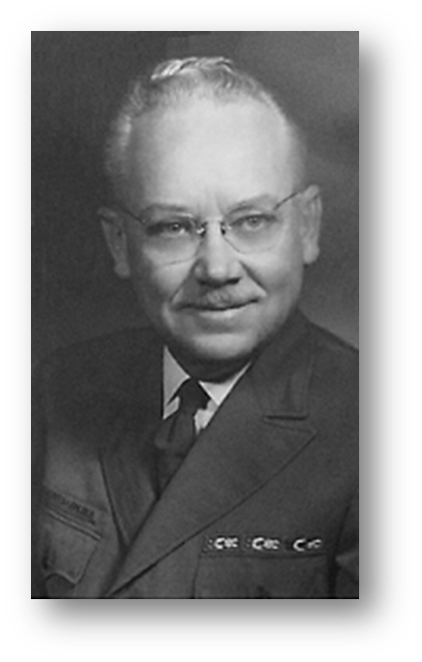
Dzie-Hauk Tonga Lodge Advisers
Dr. Clyde Merideth
Dr. Clyde Merideth | 1950-1956
Don Graves | 1956-1972
Jack Gies, Sr. | 1972-1982
Jeff Montague | 1982-1988
Craig Dunstan | 1988-1989
Scott Thomas | 1989-1990
Vern Failor | 1990-1996
George Austin | 1996-2000
Michael Johnston | 2000-2003
David Ast | 2003-2011
Jim Allman | 2011-2015
Rick Huddlestun | 2015-2018
Matt Riley | 2019-2024
Paul Rosillion | 2024-

Lodge Chiefs
The lodge chief is the elected youth leader of the lodge. The Lodge Chief is responsible for organizing and leading the various programs and activities of the lodge.

Dzie-Hauk Tonga Lodge Chiefs 1951-1995
Larry Hansen 1951 Mike Decker 1974
John Hallewell 1952 Dave Honigs 1975
Don Rolley 1953-1954 Paul Bargas 1975
Jim Pulliam 1955 Scott Miller 1975-1976
Ruval Freese 1956 Mike Hall 1977
Larry Longhofer 1957 Mike Greenlief 1978
Phil Wheeler 1958 Bruce Wiley 1979-1980
Robert Thomas, Jr. 1959 Curt Wagers 1981-1982
Robert Dolgoff 1960 Kevin Hula 1983-1984
Dennis Domer 1961-1962 Steve Anderson 1985-1986
Charles Wright III 1963-1964 John Decker 1986
Duke Collister 1964-1965 Russel Testa 1987
Dan Land 1965-1966 David Brosa 1987-1988
Mike Long 1967 Roger Billings 1988-1989
Gary Domer 1968 Eric Mayer 1989-1990
Dave Blakely 1969 Brian Hill 1990-1991
John Ossman 1969 Joran Bass 1991-1992
Jack Gies Jr. 1970 Craig Koppa 1993
Martin Gies 1971-1972 Josh Sales 1994
Jeff Montague 1973 Jason Wiley 1995

Dzie-Hauk Tonga Lodge Chiefs 1996-2025
Mark Stewart 1996 James Manning 2010-2011
Chris Austin 1997 Aaron Spicer 2012
Matt Powell 1998 Mark Spicer 2013
Eric Rubottom 1998 Thomas Bagley 2014-2015
Derek Bucheit 1999-2000 Paul Riley 2016
James Monhollan 2001 Tobias Mikkelsen 2017
Matt Puderbaugh 2002 Brenden Feldt 2018
Chris Frampton 2003 Stephen Caudill 2019-2020
Alex Ast 2004-2005 Parker Wise 2020
Nathan Huerter 2006 Andrew Kirmer 2021
Brian Jilka 2007 Nathan Basaldua 2022
Greg Scheetz 2008 Andrew Kirmer 2023
Colin Huerter 2009 Brenner Pilsl 2024
Richard Kirmer 2009 Kaylin Phillips 2025
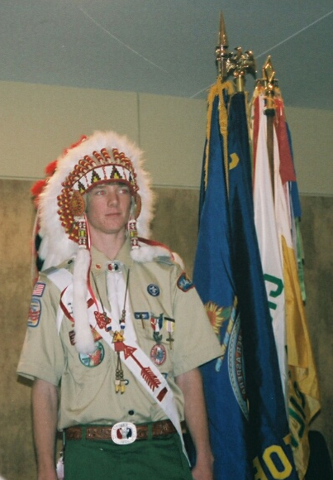
Lodge Chief Nathan Huerter

Section and Region Chiefs, Vice-Chiefs, and Secretaries
Lodges are grouped into Sections and Regions. Over the years several members of Dzie-Hauk Tonga Lodge have served both the Section and Region as Chiefs and Vice-Chiefs.

Dzie-Hauk Tonga Lodge Members Who Served as Section and Region Chiefs, Vice-Chiefs, and Secretaries
Dave Honigs Section Chief – 1975
Kevin Hula Region Chief – 1985
David Brosa Section Chief – 1988
Eric Mayer Section Vice-Chief – 1990
Alex Ast Section Vice-Chief – 2005
Nathan Huerter Section Vice-Chief – 2006
Section Secretary – 2007
Collin Huerter Region Chief – 2009
Ryan Peacocke Section Secretary – 2014
Paul Riley Section Secretary – 2017
Stephen Caudill Section Vice-Chief – 2020
Brenner Pilsl Section Vice-Chief – 2024
Interim Section Chief – Winter 2025

Roy Williams 1981-1984

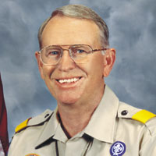
The most famous member of Dzie-Hauk Tonga Lodge was Roy Williams, chief scout executive from 2000-2007. Roy was the Jayhawk Area Council Executive from 1981 thru 1984 and achieved Vigil Honor in the lodge in 1984.

During Roy's term in Topeka he raised funds to build a new dining hall at Camp Jayhawk and purchase a larger council headquarters building right off of I-70 that is still used today.

The lodge advisor at the time reported that he had to convince Roy that he was worthy to become a vigil honor member when he was nominated.

Roy was promoted to Director of Boy Scouts when he left Topeka in 1984.

Roy returned to a Vigil reunion held at Camp Jayhawk in 2002 attended by over 50 past vigil members from the lodge.

The Nonprofit Times, a publication covering the field of nonprofit management, named Williams as one the nation's top 50 outstanding leaders of nonprofit organizations for 2005.

2019 E. Urner Goodman Camping Award
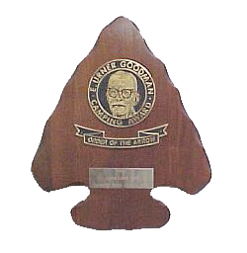
In 1969, the Order of the Arrow established the E. Urner Goodman Camping Award as a tribute and memorial to the founder of our Order. Its purpose is to encourage and challenge Order of the Arrow members and lodges to improve their effectiveness in promoting and supporting Scout camping in their councils. Each year, two lodges in each region are recognized with the award. In its 51-year history, the E. Urner Goodman Camping Award, which is the Order’s oldest national lodge award, has been presented to 233 different lodges.

Dzie-Hauk Tonga Lodge was one of two lodges from the Central region recognized with the E. Urner Goodman Camping Award for our accomplishments in 2019.

UNCAS Society
The Uncas society was started in 2004 by Lodge Chief Alex Ast as a way to increase participation in lodge activities and to raise funds toward the purchase of an OA cargo trailer. It has been continued due to the significant increased participation in the lodge. Members are awarded a special “UNCAS” lodge flap with a red border that is not otherwise sold. The Lodge Executive Council has also approved the same flap with a white border for consecutive Uncas achievers.

To become an UNCAS member, an arrowman must provide a service to the lodge such as:
- conducting multiple unit elections,
- assisting with camp promotion activities,
- make or repair American-Indian regalia,
- assisting with maintenance of the lodge website
- assisting with the publication of the newsletter
- and many others.

The Uncas lodge flap also be earned donating a minimum of $50 to the lodge for the first red bordered patch or $100 for a subsequent white bordered patch.

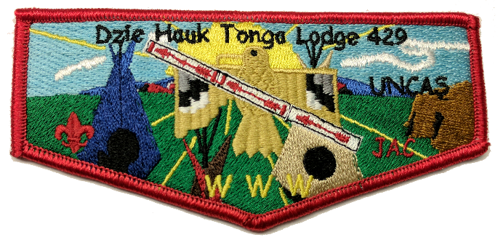
Recipients of the Uncas Award receive the red bordered patch (above) and recipients receive a white boarded patch (below) for each subsequent award.
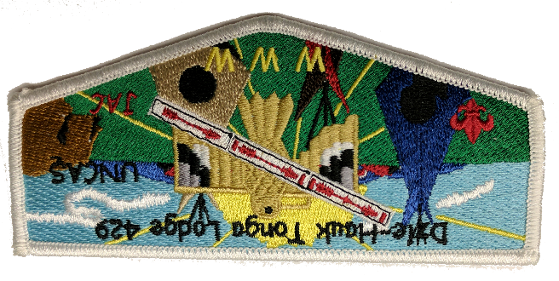

Xansati Os’Hakamink
Dear Elder Brother from Heaven
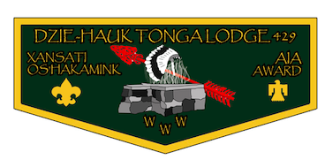
American Indian Affairs Award

The Xansati Os’Hakamink or Dear Elder Brother from Heaven American Indian Affairs Award was created by the lodge in 2021. Its name honors AIA advisers George Goldring, Jim Galvin, and Mike Ballard for their outstanding service to the lodge’s AIA program.

The award is to recognize youth Arrowmen who have dedicated much of the time within our lodge as members of the either the Ceremonies, Dance or Drum team. Adult Arrowmen may also earn this award at the discretion of the lodge’s AIA teams. Many years of dedicated service are required to be eligible for this award. This award may only be earned once.

Xansati Os’Hakamink Recipients

2022
Nathan Basaldua, Andrew Kirmer, Thomas Bagley, Brenden Feldt,
Brock Lowman, Paul Riley, Matt Riley, George Waters

2023
Charles Edington, Nate Waters

Section G6 RD Dunkin Leadership in Service Award

Purpose: This award is designed to recognize those within Section G6 who go far beyond their immediate responsibilities as Arrowmen and by doing so have laid a path of excellence for other Arrowmen to follow. The award is named after R.D. Dunkin, who believed that young people can grow to exceptional strengths and reach their full potential with the right combination of leadership, education, mentorship, and love. R.D. Dunkin served as the Central Region Order of the Arrow Chairman for sixteen years and is responsible for shaping the region structure and program.

RD Dunkin Leadership in Service Award Recipients

2019 Paul Riley

2023 Nathan Basaluda

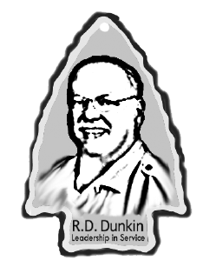

Camp Jayhawk

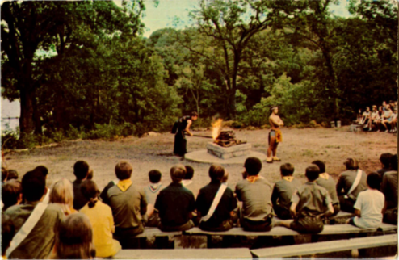
The camp is located approximately 20 miles northeast of Topeka or just east of the Lake Perry Reservoir in one of the most scenic areas in Kansas.

Most of camp is in a wooded area surrounding 5-acre Lake Jayhawk where all of the aquatics activities occur. It is part of the 340-acre Falley Scout Reservation that was renamed in 1994.

In 1994 an additional 40 acres of grassy meadow was purchased. The west side of the camp now has 13 campsites used for summer camp. They are big enough so that tent sites are rotated every 3 years to keep the grass intact. The ponds and lake have excellent fishing and a big nature trail that goes through the area.

Camp Pioneer on the east side was closed in 1994 but was once used for summer camp where campers cooked their own meals for the week. The north campgrounds have been used for winter camping since the meadow was purchased. Also, on the north side a shotgun range and the COPE course were built in the mid 1990's.

There are many trails to make easy access to the central 'parade' grounds where the dining hall, some staff cabins and several other office buildings are located including Wingfoot lodge, the OA headquarters. 3 chapels and 2 climbing towers are just off the parade grounds. Below the parade grounds is the Inspiration Point amphitheater where most campfire activities are held. Inspiration Point or "I.P." overlooks the lake and provides one of the most spectacular views in the state.

The OA ceremonial grounds are located in a secluded area on the northeast side of the lake. Dying Elm was built in 1962. This area can hold over 200 arrowmen for ceremonies and provides another spectacular view overlooking Lake Jayhawk. Most pre-ordeal activities are conducted at Five Fires, a grassy spot in the woods close to Dying Elm with 5 fire altars representing the chapters that made up the lodge at the time were made in the mid 1960’s.

Camp Jayhawk offers almost 30 merit badges as well as an extensive first-class emphasis system for 11-year-old scouts. It has one of the finest COPE courses in the country as well as 2 big climbing towers and shooting sports. Many older scouts’ sign up for the nearby high adventure package that canoes on the Delaware River and Lake Perry as well as hiking an historic military trail.

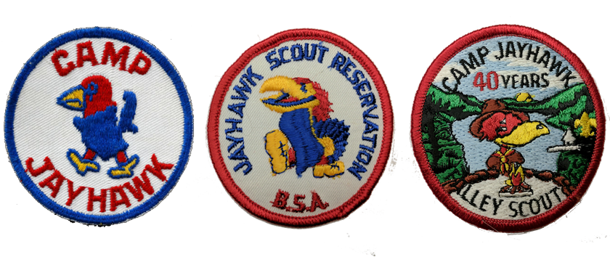

Dzie-Hauk Tonga Lodge History
Formal action of the Executive Board was taken in March 1950, and an application for Charter was made shortly thereafter, T.M. Clymer, William Kruzan and J.W. Norfolk, who were members of the Order of the Arrow in other councils formed the organizational team. Considerable time was spent in the Kansas Historical Society looking up Indian legends on history of Indian tribes in order that the name might be selected for the Lodge.
It was decided to hold the first organization meeting on Saturday and Sunday, May 6th and 7th and that with the help of Don Palmer, who had transferred from the Sioux Council of Sioux Falls, SD, the installation of outstanding adult campers was made and all of the Scouts who had been elected as honor campers at Camp Jayhawk in 1949, plus a few who had been members of the Camp Staff and who had been outstanding campers, were invited to become charter members.
Eighty members in all were invited to participate. For various reasons, some could not attend. Of these invited, forty-seven were taken into the Order of the Arrow. The regular Ordeal program was carried out and at the close of the Sunday evening ceremony, the following men and young men were elected as members of the Lodge Council.
Carroll Reichert |  | William Kruzan
Don Graves |  | J.W. Norfolk
Harvey Ray |  | Merle Harrison
Ed Mammon |  | Dr. Clyde O. Merideth
Robert Bannerman |  | T.M. Clymer
Clinton Stalker |  | Joe Jarbour
The group had a small meeting after the ceremonies and decided that the original meeting of this group for the purpose of developing a Constitution and By-laws for the Lodge would be held at the Martin Tractor Company in Topeka on May 18th.
Our first Lodge Chief was Larry Hansen who served in 1951.

The totem of our lodge is the Dzie-Hauk-Wa-Kon-Da the Thunderbird.

Traditions of Dzie-Hauk Tonga Lodge

The Sacred Circle

On April 25th, 1957 the following traditions were accepted by the Lodge Council after a presentation of the Traditions Committee.

- Our Lodge Circle shall be called “Dying Elm Lodge Circle”.

- An Arrowman before entering the sacred circle will stand erect in the entrance with arms folded. The Arrowman will raise both hands and face heavenward and will bow three times before returning the arms to the original position, at which time the Arrowman will silently enter the ring. The three bows are a witness to fellow Arrowmen of dedication to the principals symbolized by the three fires in front of the Chief’s Lectern. “Bowing in” is an individual dedication and need not be coordinated with others entering or leaving at the same time.

- An Arrowman working in or around the circle will only pay respects by bowing upon the first entrance and the last exit.

- When ready to leave, one will follow the same procedure as used for entrance, except the Arrowman will only bow once. “Bowing out” is an individual dedication and need not be coordinated with others entering or leaving at the same time.

- No one but an Order of the Arrow member and his Dear Mother shall be permitted to enter the Sacred Circle except with the permission of the Supreme Chief of the Lodge.

- As a matter of courtesy to the Chief of the Lodge, no one should pass between the Central Altar Fire and the Chief’s Lectern.

- The Sacred Circle is to be entered only at the designated entrance.

- Within twenty-four hours after returning to the camp reservation for any purpose, a faithful Arrowman will quietly return to the Sacred Circle and select some spot to kneel in silent or audible prayer.

Prepare for Grace

The following tradition was added by the lodge in 1959.

- Arrowmen will take the “position of prayer” for Order of the Arrow meals and meals at Camp Jayhawk. The Arrowman will stand with arms folded then extended and hands heavenward and remain with uplifted arms until the conclusion of the prayer.

Questions or Comments

If you have any questions or comments about this book, contact me at the information below or any Lodge officer or adviser.

Thank you.

WWW,
Josh Evans | Associate Lodge Adviser for Unit Relations
ORDER OF THE ARROW
Dzie-Hauk Tonga Lodge
jaeagle1742@gmail.com

